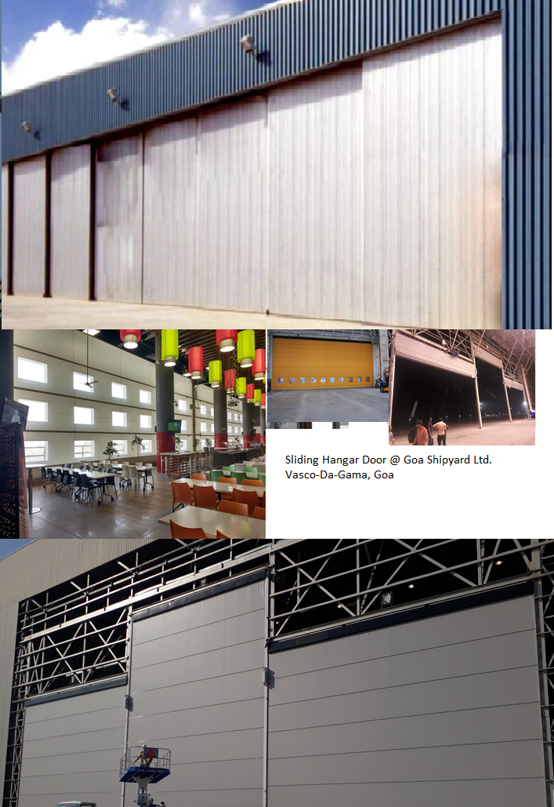

To, Date: 22.01.2021
Mr. K. Elango Quotation No: SQT/20-21/ 2432R
SMP
Goa Shipyard Ltd
elango@goashipyard.com

Project: Non-Comprehensive Annual Maintenance Contract for Hangar Doors in Goa Shipyard Ltd (GSL), Vasco Da Gama.

Dear Sir,

We thank you and based on our successive discussions we are pleased to submit our proposal for Non-comprehensive Annual Maintenance Contract Quotation.

Preventive maintenance is a way to ensure you trouble free operations.

Your benefits:
- Prevents unexpected and expensive break-downs
- Prolongs lifetime
- Cost saving
- Minimizes risk of personal injury
- Minimizes energy loss
- Fulfills legal requirements

Additional benefits: You will get priority in case of breakdowns.

For more information do not hesitate to contact our customer Service department

Yours faithfully
Santosh Bangar
Service Department
Email: service@nihva.com
Mob: 9168938333

About Us:

“NIHVA” pioneers in offering intelligent, innovative and economical ‘Solutions’. We are proud of our products and service range offered with a high level of working safety, comfort, functionality and supported by value added solutions & services.
We understand the importance of manpower in providing such services to our esteemed customers and therefore we have best Technician, Engineers to ensure trouble free services. Our values and culture drive team empowerment and trusted customer relationships. Our business partners / associates are global market leaders & specialize in application knowledge. The combination of this knowledge & our expertise allows us to appreciate unique business challenge and to support you with the most efficient solution. Our head office is located at Pune in Maharashtra (India). “NIHVA” has always been strongly supported by world leaders in automation. Our commitment is to execute projects with highest quality, on time & within the budget, while adhering to safety, health and environmental standards and to get established as an icon in providing best engineering services

Prequalification criteria:

“NIHVA” has always been strongly supported by world leaders in automation and have annual turnover of not less than EIGHT Crore per year during last three financial years. Our commitment is to execute projects with highest quality, on time & within the budget while adhering to safety, health and environmental standards and to get established as an icon in providing best engineering, solutions, services and products.
NIHVA is equipped with sophisticated tools and trained engineers to provide quick and efficient service to ensure minimum downtime, prevent unexpected breakdowns and safe work environment.
NIHVA is pioneer in installations & service of the higher capacity hanger doors (10Nos Hanger door) and having more than 3 years of experience in maintaining the hanger door.

Annual Maintenance Contract

This agreement is between M/s. NIHVA Technologies Pvt Ltd, 187 G-Block, Thermax Chowk, Chinchwad MIDC, Pune-411019 and Goa Shipyard Ltd, Vasco Da Gama. This agreement is for HANGAR Door-Gandhi make installed at M/s Goa Shipyard Ltd (GSL), Vasco Da Gama and the agreement includes:

SLIDING HANGAR DOOR

- Scope of Work
A maintenance contract for general maintenance, minor and major repairs to upkeep the hanger door (12 Nos) in healthy working condition throughout the contract period.
  - The following maintenance is carried out on each hanger doors,
  - Periodical Preventive Maintenance - once in 6 months ( 2 visit/Year)
  - Breakdown Maintenance – As and when required at Extra cost 15000/- per visit( one free breakdown visit in contract period)
  - In case of any Hanger door PM need to be done additionally on request of GSL, the NIHVA shall undertake such work at the rates quoted and payment will be made accordingly.
  - During the above maintenance, NIHVA will carry out both electrical and mechanical maintenance.
  - After completion of the maintenance on each sliding door the NIHVA will fill up the checklist and take signed by the GSL supervisor. The checklist will be provided to GSL along with invoices.
  - In addition to Periodical preventive maintenance (PPM) once in six months NIHVA will attend one free breakdown call occurring at any time, at no extra cost.
  - The transportation and arrangement for lodging & boarding for maintenance team during contact will be in NIHVA scope.

Key Personnel - Service Dept.
Sr no. | Name | Designation | Contact  number | E mail address
1 | Mr. Santosh Bangar | Sr. Project Engineer | 9168938333 | service@nihva.com
2 | Mr. Amit Kurhade | Asst. General Manager | 7410172333 | amit.kurhade@nihva.com

2. Duration of the Contract & Validation of Quotation:
The period of contract will be for the Three year from 01-01-2021 to 31-12-2023

SN | Product | Year Considered | Rate/door/2 visit/year | Qty of Door | Total Amount
SN | Product | Year Considered | (INR) | Qty of Door | (INR)
1 | Hanger Door--Four leaf | 01.01.2021-31.12.2021 | 10,00,000 | 5 | 10,00,000
1 | Hanger Door-Double leaf and single leaf | 01.01.2021-31.12.2021 | 12,60,000 | 7 | 12,60,000
2 | Hanger Door--Four leaf | 01.01.2022-31.12.2022 | 11,00,000 | 5 | 11,00,000
2 | Hanger Door-Double leaf and single leaf | 01.01.2022-31.12.2022 | 13,86,000 | 7 | 13,86,000
3 | Hanger Door--Four leaf | 01.01.2023-31.12.2023 | 12,10,000 | 5 | 12,10,000
3 | Hanger Door-Double leaf and single leaf | 01.01.2023-31.12.2023 | 15,24,600 | 7 | 15,24,600

2.1. Total Sliding Hangar doors to be maintained= 12 Nos.

Sr.No | Location of the Doors | Door Size  (w x h)mm | Model/type | Qty
1 | SOW Building | 14000 x 10000 | Three Leaf | 1
2 | SAW Bay -2 Between Grid B &C North side | 25000 x 30000 | Four leaf | 1
3 | SAW Bay -1 Between Grid A &B North side | 25000 x 30000 | Four leaf | 1
4 | SAW Bay -1 Between Grid A &B South side | 25000 x 15000 | Four leaf | 1
5 | SAW Bay -2 Between Grid B & C South side | 25000 x 15000 | Four leaf | 1
6 | SAW Bay -1 Grid A Between 8 & 9 | 11000 x 12000 | Double leaf | 1
7 | SAW Bay -2 Grid C Between 8 & 9 | 11000 x 12000 | Double leaf | 1
8 | SAW Bay -2 Grid C Between 3 & 4 | 11000 x 12000 | Double leaf | 1
9 | SAW Bay -1 Grid A Between 3 & 4 | 11000 x 12000 | Double leaf | 1
10 | GRP Workshop (Grid 20) | 34400 x 15000 | Four leaf | 1
11 | GRP Workshop (Grid 8) | 17400 x 15000 | Four leaf | 1
12 | Mold Bay (Grid 3) | 5000 x 5000 | Single leaf | 1
3. Working hours:

- General working timings for the maintenance staff including supervisor is 09.00hrs to 17.30 hrs. on working days(Monday to Saturday)
- The actual schedule will be confirmed by Service-Manager NIHVA & informed to GSL sufficient time in advance for planning the resources.

4. Manpower Required for Work:
NIHVA is equipped with sophisticated tools and trained engineers to provide quick and efficient service.

SN | Category | Qualification & Experience | Minimum Required Person
1 | Supervisor | Diploma/ Degree in Mechanical/Electrical engineering with 4 years of Experience | 1
2 | Technician/Fitter | 3 years of experience in installation and service of hanger door | 1
3 | Electrician | 3 years of experience in installation and service of hanger door | 1
4 | Helpers | 3 years of experience in installation and service of hanger door | 2

5. General Check-Points:

SN | Mechanical checkpoint | Electrical: Check Points
1 | Assembly checking. | Main electric connections with motor & control panel connections.
2 | Alignment of door leafs | Limit Switch Setting.
3 | Oiling/ greasing to wheels | Control Box: Connectors, relay, overhead protection, switches.
4 | Other alignment & interlocking checking. | Safety sensor and devices
5 | All Nuts-Bolts tightening. | Electrical cable connections
6 | Structural joints and framing | Proximity switches
7 | Gear box and drive system | Push button and emergency switches
8 | Sheets | Electrical contactors

6. Prerequisites for Service - Client Scope

- The above terms do not apply in case of abuse, misuse, misapplication or any defects arriving due to negligence or accident. An extra cost will be applicable for Extra Man Power for extra. Day (if required) + Spares & payable by you will be quoted separately.

- The above terms do not apply to such products which shall have been installed, altered, or Repaired by any non-authorized person

- Any spare part/ component (if) required, will be at extra costs at actual are not inclusive in the maintenance contract. In case of unavailability of the any spare part due to any reason during maintenance GSL shall arrange/provide the same from OEM.

- Required Forklift / Scaffolding/ Crane and necessary help to our service Engineers from client during maintenance of each door in addition to any other charges or fees specified in this Agreement.

- Additional Costs and Charges: The cost of materials and major repair if any or extra services shall be charged extra with GSL approval.

- In addition, on-site maintenance calls (a) in which the Equipment was not the cause of the reported trouble (b) where no trouble was found or © where the call was due to Customer or its representatives improperly following operating instructions for the Equipment, will be billed separately.

- Replacement of materials, spares, components and consumables like oil etc., will be supplied by the GSL.

- If due to any reason our person need to wait beyond working duration, then Rs. 7500/- per day per person working charges will be charged extra.

- Replacement of materials, spares, components and consumables like oil etc., will be supplied by the GSL.

7. Other Terms & conditions:
- GST : Extra 18%
- Validity : Validity of offer is 15 days from the date of quotation.
- Payment : 100% advance immediately after the submission of Tax invoice
- Price : Ex-works Pune

GST Pune: 27AAECN0437H1ZM
SAC Code: 998732

Please feel free to Contact Mr. Vijay Tarak on 08551093333 for any further Clarification /Information in this Concern.

Regards,
Santosh Bangar
Service Dept.
NIHVA Technologies Pvt Ltd.

